**A Virtual Voice Assistant**

**A Project Report**

***Submitted by:***

**RANGOLI JAISWAL (191B199)**

**RISHI NEELKANTH (191B201)**

**SEJAL JAIN (191B223)**

***in partial fulfillment for the award of the degree***

***of***

**BACHELOR OF TECHONOLOGY**

**IN**

**COMPUTER SCIENCE AND ENGINEERING**

***at***



**JAYPEE UNIVERSITY OF ENGINEERING & TECHNOLOGY**

**GUNA , MADHYA PRADESH (INDIA) – 473226**

**DECLARATION**

I hereby declare that the project entitled “A Virtual Voice Assistant” submitted for the B. Tech. (CSE) degree is my original work and the project has not formed the basis for the award of any other degree, diploma, fellowship or any other similar titles.

**Place:**

**Date:**

**Rangoli jaiswal (191b199)**

**signature**

**Rishi neelkanth (191b201)**

**signature**

**Sejal jain(191b223)**

**signature**

**CERTIFICATE**

This is to certify that the project titled “A Virtual Voice Assistant” is the bona fide work carried out by RANGOLI JAISWAL (191B199), RISHI NEELKANTH (191B201) and SEJAL JAIN (191B223) students of B Tech (CSE) of Jaypee University of Engineering and Technology, Guna (M.P), during the academic year 2020-21, in partial fulfillment of the requirements for the award of the degree of Bachelor of Technology (Computer Science and Engineering ) and that the project has not formed the basis for the award previously of any other degree, diploma, fellowship or any other similar title.

**Place:**

**Date:**

**Signature of the Guide**

**Dr.Neelesh kumar Jain**

**Assistant Professor(SG)**

**ABSTRACT**

Technology has advanced at an exponential rate over time. Artificial intelligence (AI) is primarily concerned with the creation of natural dialogue between humans and machines. Artificial intelligence is becoming increasingly prevalent in human existence. The science of recognizing a human's natural language is one of the most important trends in artificial intelligence. Voice assistants are a ground breaking AI innovation that has the potential to transform people's lives in a variety of ways. The voice assistant was first offered on cell phones, where it quickly gained popularity. It was universally recognised. The voice assistant was first introduced in smartphones and laptops, but it is now available in smart speakers and home automation.

**ACKNOWLEGEMENT**

We have invested a lot of time and efforts in completion of this project but this project would not have been possible without the kind support of various individuals and organizations, we hereby extend our sincerest gratitude to all of them. We are highly indebted to our faculty DR. Neelesh Kumar Jain . We would like to thank him for his constant guidance and supervision. We would like to thank the JUET for providing us with such supportive and innovative environment facilities and lending us their support whenever required.

We will also like to thank the whole as an organization for providing us with such opportunities. At last we all will like to thank and congratulate our fellow project members for their hard-work and dedication.

**LIST OF FIGURES**

|  |  |  |
| --- | --- | --- |
| **Figure** | **Title** | **Page No.** |
| Figure 3.1 | Workflow | 16 |
| Figure 3.2 | Use Case Diagram | 17 |
| Figure 3.3 | Block Diagram | 18 |
| Figure 3.4 | Design and Test Steps | 18 |
| Figure 3.5 | Testing Process | 19 |

**TABLE OF CONTENT**

Title Page i

Declaration of the Student ii

Certificate of the Guide iii

Abstract iv

Acknowledgement v

List of Figures vi

**1. INTRODUCTION**

1.1 Problem Definition

1.2 Project Overview/Specifications

1.3 Hardware Specification

1.4 Software Specification

**2. LITERATURE SURVEY**

2.1 Existing System

2.2 Proposed System

2.3 Feasibility Study

**3. SYSTEM ANALYSIS & DESIGN**

3.1 Requirement Specification

3.2 Flowcharts / DFDs / ERDs

3.2.1 Use Case Diagram

3.2.2 ER Diagram

3.3 Design and Test Steps

**4. RESULTS / OUTPUTS**

**5. CONCLUSIONS / RECOMMENDATIONS**

**6. REFERENCES**

**7. APPENDICES**

**7.1 Details of software/simulator if any**

**7.2 Steps to execute/run/implement the project**

1. **INTRODUCTION**

The application of Virtual Assistants (VAs) is growing fast in our personal and professional life. It has been predicted that 25% of households using a VA will have two or more devices by 2021 . A virtual assistant is an intelligent application that can perform tasks or provide services for a person responding to orders or inquiries. Some VAs can understand and respond to human speech using synthesized voices. Users may use voice commands to request their VA to answer the questions, manage home appliances, control media playing, and handle other essential activities like email, creating the actions lists, and organize the meetings on calendars . In the Internet of Things (IoT) world, an VA is a popular service to communicate with users based on voice command.

VA capabilities and usage are rapidly rising, thanks to new technologies reaching the people’s requirements and a robust focus on voice user interfaces. Samsung, Google, and Apple each have a considerable smartphone user base. Microsoft’s Windows-based personal computers, smartphones, and smart speakers have an intelligent VA installed base. On Amazon, smart speakers have a sizable installed base . Over 100 million people have used Conversica’s short message and email interface Intelligent Virtual Assistants (IVAs) services in their companies.

Famous virtual assistants like Amazon Alexa and Google Assistant are typically cloud-based for maximum performance and data management. Many behavioral traces, including the user’s voice activity history with extensive descriptions, can be saved in a VA ecosystem’s remote cloud servers during this process.

**1.1 Problem Definition**

The project we are making is a virtual voice assistant which will recognize the users voice and perform the task as directed by the user ,this will be a totally hand free experience for the user and user will be able to do many works with the help of this voice assistant.

**1.2 Project Overview/Specifications**

Project overview are the silent features of the project , the services which it will provide to the user and the user interface .

* It can open notepad ,calculator and other desktop applications etc .
* It can open google as well as can open a website directly from voice command.
* It can open youtube and can directly open any youtube video.
* It can tell you a joke.
* It can get information about anyone using Wikipedia.
* It can also reply back for some commands.

**1.3 Hardware Specification**

Hardware Specification means the minimum technical specification and configuration that must be met by the Hardware in order to ensure the correct operation of the Software.

Table no-01

|  |  |  |
| --- | --- | --- |
| **Component** | **Minimum** | **Recommended** |
| Processor | 1.9 gigahertz (GHz) x86- or x64-bit dual core processor with SSE2 instruction set | 3.3 gigahertz (GHz) or faster 64-bit dual core processor with SSE2 instruction set |
| Memory | 2-GB RAM | 4-GB RAM or more |
| Display | Super VGA with a resolution of 1024 x 768 | Super VGA with a resolution of 1024 x 768 |

**1.4 Software Specification**

A software requirements specification (SRS) is a document that describes what the software will do and how it will be expected to perform. It also describes the functionality the product needs to fulfill all stakeholders needs:

* Google Chrome (latest publicly-released version) running on Windows 11, Windows 10, Windows 8.1
* Google Chrome (latest publicly-released version) running on the two latest publicly-release Mac OS versions
* Windows 7 or above

**2. LITERATURE SURVEY**

**2.1 Existing System**

Existing System means a system which is currently in use and is running successfully with user all around the world .

Google Assistant , Siri and Alexa are the few existing system similar to this project in different ways.

**2.1.1 Google Assistant**

Google Assistant is a [virtual assistant](https://en.wikipedia.org/wiki/Virtual_assistant) software application developed by [Google](https://en.wikipedia.org/wiki/Google) that is primarily available on [mobile](https://en.wikipedia.org/wiki/Mobile_device) and [home automation](https://en.wikipedia.org/wiki/Home_automation) devices. Based on [artificial intelligence](https://en.wikipedia.org/wiki/Artificial_intelligence), Google Assistant can engage in two-way conversations, unlike the company's previous virtual assistant, [Google Now](https://en.wikipedia.org/wiki/Google_Now).

Google Assistant debuted in May 2016 as part of Google's messaging app [Allo](https://en.wikipedia.org/wiki/Google_Allo), and its voice-activated speaker [Google Home](https://en.wikipedia.org/wiki/Google_Home). After a period of exclusivity on the [Pixel and Pixel XL](https://en.wikipedia.org/wiki/Pixel_(smartphone)) smartphones, it was deployed on other [Android](https://en.wikipedia.org/wiki/Android_(operating_system)) devices starting in February 2017, including third-party smartphones and Android Wear (now [Wear OS](https://en.wikipedia.org/wiki/Wear_OS)), and was released as a standalone app on the [iOS](https://en.wikipedia.org/wiki/IOS) operating system in May 2017. Alongside the announcement of a [software development kit](https://en.wikipedia.org/wiki/Software_development_kit) in April 2017, Assistant has been further extended to support a large variety of devices, including cars and third-party smart home appliances. The functionality of the Assistant can also be enhanced by third-party developers.

Users primarily interact with the Google Assistant through [natural voice](https://en.wikipedia.org/wiki/Natural_language_processing), though keyboard input is also supported. Assistant is able to answer questions, schedule events and alarms, adjust hardware settings on the user's device, show information from the user's Google account, play games, and more. Google has also announced that Assistant will be able to identify objects and gather visual information through the device's camera, and support purchasing products and sending money[1].

**2.1.2 Siri**

Siri is a [virtual assistant](https://en.wikipedia.org/wiki/Virtual_assistant) that is part of [Apple Inc.](https://en.wikipedia.org/wiki/Apple_Inc.)'s [iOS](https://en.wikipedia.org/wiki/IOS), [iPadOS](https://en.wikipedia.org/wiki/IPadOS), [watchOS](https://en.wikipedia.org/wiki/WatchOS), [macOS](https://en.wikipedia.org/wiki/MacOS), [tvOS](https://en.wikipedia.org/wiki/TvOS), and [audioOS](https://en.wikipedia.org/wiki/AudioOS) [operating systems](https://en.wikipedia.org/wiki/Operating_system). It uses voice queries, gesture based control, focus-tracking and a [natural-language user interface](https://en.wikipedia.org/wiki/Natural-language_user_interface) to answer questions, make recommendations, and perform actions by delegating requests to a set of [Internet](https://en.wikipedia.org/wiki/Internet) services. With continued use, it adapts to users' individual language usages, searches and preferences, returning individualized results.

Siri is a [spin-off](https://en.wikipedia.org/wiki/Corporate_spin-off) from a project developed by the [SRI International](https://en.wikipedia.org/wiki/SRI_International) Artificial Intelligence Center. Its [speech recognition](https://en.wikipedia.org/wiki/Speech_recognition) engine was provided by [Nuance Communications](https://en.wikipedia.org/wiki/Nuance_Communications), and it uses advanced [machine learning](https://en.wikipedia.org/wiki/Machine_learning) technologies to function. Its original American, British and Australian [voice actors](https://en.wikipedia.org/wiki/Voice_acting) recorded their respective voices around 2005, unaware of the recordings' eventual usage. Siri was released as an app for iOS in February 2010. Two months later, Apple acquired it and integrated into [iPhone 4S](https://en.wikipedia.org/wiki/IPhone_4S) at its release on 4 October, 2011, removing the separate app from the iOS [App Store](https://en.wikipedia.org/wiki/App_Store_(iOS)). Siri has since been an integral part of Apple's products, having been adapted into other hardware devices including newer [iPhone](https://en.wikipedia.org/wiki/IPhone) models, [iPad](https://en.wikipedia.org/wiki/IPad), [iPod Touch](https://en.wikipedia.org/wiki/IPod_Touch), [Mac](https://en.wikipedia.org/wiki/Macintosh), [AirPods](https://en.wikipedia.org/wiki/AirPods), [Apple TV](https://en.wikipedia.org/wiki/Apple_TV), and [HomePod](https://en.wikipedia.org/wiki/HomePod) [2].

**2.1.3 Alexa**

Amazon Alexa, also known simply as Alexa, is a [virtual assistant](https://en.wikipedia.org/wiki/Virtual_assistant) technology largely based on a Polish speech synthesiser named Ivona, bought by [Amazon](https://en.wikipedia.org/wiki/Amazon_(company)) in 2013. It was first used in the [Amazon Echo](https://en.wikipedia.org/wiki/Amazon_Echo) [smart speaker](https://en.wikipedia.org/wiki/Smart_speaker) and the [Echo Dot](https://en.wikipedia.org/wiki/Amazon_Echo_Dot), Echo Studio and [Amazon Tap](https://en.wikipedia.org/wiki/Amazon_Tap) speakers developed by [Amazon Lab126](https://en.wikipedia.org/wiki/Amazon_Lab126). It is capable of voice interaction, music playback, making to-do lists, [setting alarms](https://en.wikipedia.org/wiki/Alarm_clock), streaming podcasts, playing audiobooks, and providing weather, traffic, sports, and other real-time information, such as [news](https://en.wikipedia.org/wiki/News). Alexa can also control several [smart devices](https://en.wikipedia.org/wiki/Smart_device) using itself as a [home automation](https://en.wikipedia.org/wiki/Home_automation) system. Users are able to extend the Alexa capabilities by installing "skills" (additional functionality developed by third-party vendors, in other settings more commonly called [apps](https://en.wikipedia.org/wiki/Mobile_app)) such as weather programs and audio features. It uses automatic speech recognition, natural language processing, and other forms of [weak AI](https://en.wikipedia.org/wiki/Weak_AI) to perform these tasks.

Most devices with Alexa allow users to activate the device using a wake-word (such as Alexa or Amazon); other devices (such as the Amazon mobile app on [iOS](https://en.wikipedia.org/wiki/IOS) or [Android](https://en.wikipedia.org/wiki/Android_(operating_system)) and Amazon Dash Wand) require the user to click a button to activate Alexa's listening mode, although, some phones also allow a user to say a command, such as "Alexa" or "Alexa wake"[3].

**2.2 Proposed System**

The proposed system is a virtual voice assistant which is designed for an individual rather than for everyone having functionalities which user wants , it do not serve all functionalities similar to other voice assistants available in the market.

**2.3 Feasibility Study**

A feasibility study is an analysis that considers all of a project's relevant factors including economic, technical, legal, and scheduling considerations to ascertain the likelihood of completing the project successfully.

**2.3.1 Operational Feasibility**

It is the ease and simplicity of operation of the proposed system.System does not require any special skill set for users to operate it. In fact, it is designed to be used by almost everyone. Kids who still don’t know how to write can readout problems for the system and get answers.

**2.3.2 Technical Feasibility**

It includes finding out technologies for the project, both hardware and software. For a virtual assistant, the user must have a microphone to convey their message and a speaker to listen when the system speaks. These are very cheap nowadays and everyone generally possesses them. Besides, the system needs internet connection.While using Alex , make sure you have a steady internet connection. It is also not an issue in this era where almost every home or office has Wi-Fi.

**2.3.3 Economical Feasibility**

Here, we find the total cost and benefit of the proposed system over the current system. For this project, the main cost is documentation cost. Useralso would have to pay for a microphone and speakers. Again, they are cheap and available. As far as maintenance is concerned, Alex won’t cost too much.

**2.3.4 Organizational Feasibility**

This shows the management and organizational structure of the project. This project is not built by a team. The management tasks are all to be carried out by a single person. That won’t create any management issues and will increase the feasibility of the project

**2.3.5 Cultural Feasibility**

It deals with compatibility of the project with the cultural environment. Virtual assistant is built in accordance with the general culture. The project is named Alex so as to represent Indian culture without undermining local beliefs.

This project is technically feasible with no external hardware requirements. Also it is simple in operation and does not cost training or repairs. Overall feasibility study of the project reveals that the goals of the proposed system are achievable. Decision is taken to proceed with the project.

**3. SYSTEM ANALYSIS & DESIGN**

**3.1 Requirement Specification**

System analysis entails gaining a thorough grasp of existing systems and determining where they fail. The solution is intended to address problems with the proposed system. It is the system's definition. The system is broken down into smaller pieces. In system analysis, the functions and interrelationships of various modules are investigated. The whole analysis may be seen below.

**Python**

Python is a high-level, interpreted programming language based on OOPs (Object Oriented Programming). It's a powerful, practical language designed for quick application development (RAD). Python facilitates code writing and execution. When compared to other OOP languages, Python may implement the same logic with as little as 15% of the code.

Python has a long list of advantages for everyone. Python is so versatile that it can't be used for just one thing. Its increasing popularity has allowed it to penetrate some of the most popular and sophisticated processes, including as Artificial Intelligence (AI), Machine Learning (ML), Natural Language Processing (NLP), Data Science, and so on. Python has many libraries to meet this project's needs. Speech recognition for voice recognition, Pyttsx for text to speech, and Selenium for web automation are among the libraries used by Alex[4].

**gTTS**

The gTTS API supports several languages including English, Hindi, Tamil, French, German and many more. The speech can be delivered in any one of the two available audio speeds, fast or slow. However, as of the latest update, it is not possible to change the voice of the generated audio[5].

**Speech Recognition**

Speech Recognition or Automatic Speech Recognition (ASR) is the center of attention for AI projects like robotics. Without ASR, it is not possible to imagine a cognitive robot interacting with a human. However, it is not quite easy to build a speech recognizer[6].

**Webbrowser**

In Python, webbrowser module is a convenient web browser controller. It provides a high-level interface that allows displaying Web-based documents to users. webbrowser can also be used as a CLI tool[7].

**Smtplib**

Python provides smtplib module, which defines an SMTP client session object that can be used to send mail to any Internet machine with an SMTP or ESMTP listener daemon. host − This is the host running your SMTP server. You can specify IP address of the host [8].

**Os**

The OS module in Python provides functions for interacting with the operating system. OS comes under Python’s standard utility modules. This module provides a portable way of using operating system-dependent functionality[9].

**3.2 Flowcharts / DFDs / ERDs**

In this project we have the Workflow ,Use case Diagram and Block Diagram which describes the project’s internal working in a more elaborative way.

**3.2.1 Workflow**

A workflow diagram (also known as a workflow) provides a graphic overview of the business process. Using standardized symbols and shapes, the workflow shows step by step how your work is completed from start to finish. It also shows who is responsible for work at what point in the process[10].

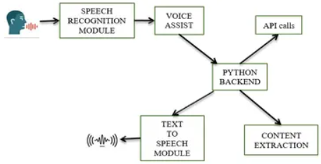

**Figure 3.1 Workflow of Virtual assistant**

**3.2.2 Use Case Diagram**

A use case diagram is a graphical depiction of a user's possible interactions with a system. A use case diagram shows various use cases and different types of users the system has and will often be accompanied by other types of diagrams as well. The use cases are represented by either circles or ellipses.

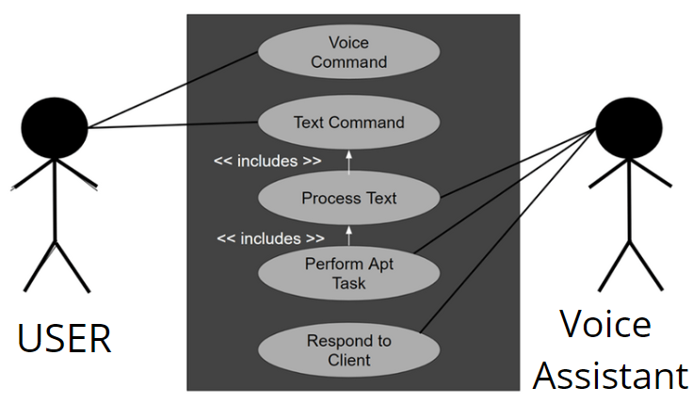

**Figure 3.2 Use Case Diagram of Voice assistant**

**Explanation**

**Voice Command** – User giving voice command to be executed.

**Text Command** – User giving command in the form of text.

**Process Text** – User’s voice is converted to text and processed .

**Perform Apt Task** – Task assigned by user is executed by the assistant.

**Respond to Client** – After execution of task response is given to the user.

**3.2.2 Block Diagram**

A block diagram is a visual representation of a system that uses simple, labeled blocks that represent single or multiple items, entities or concepts, connected by lines to show relationships between them.

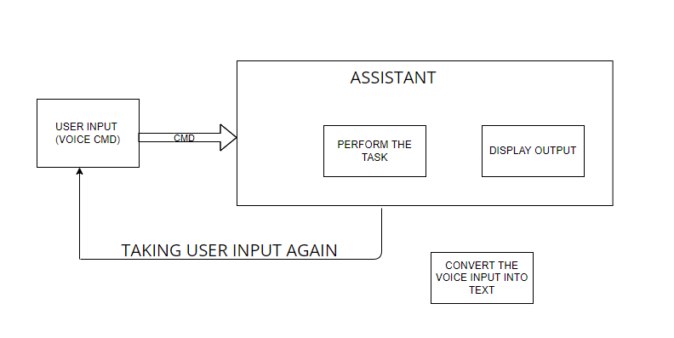

**Figure 3.3 Block Diagram of Virtual assistant**

**3.3 Design and Test Steps**

A test design is developed to portray the test effort, in order to give project and test personnel a mental framework on the boundary and scope of the test program. Following test analysis, the test team develops the test program design models.

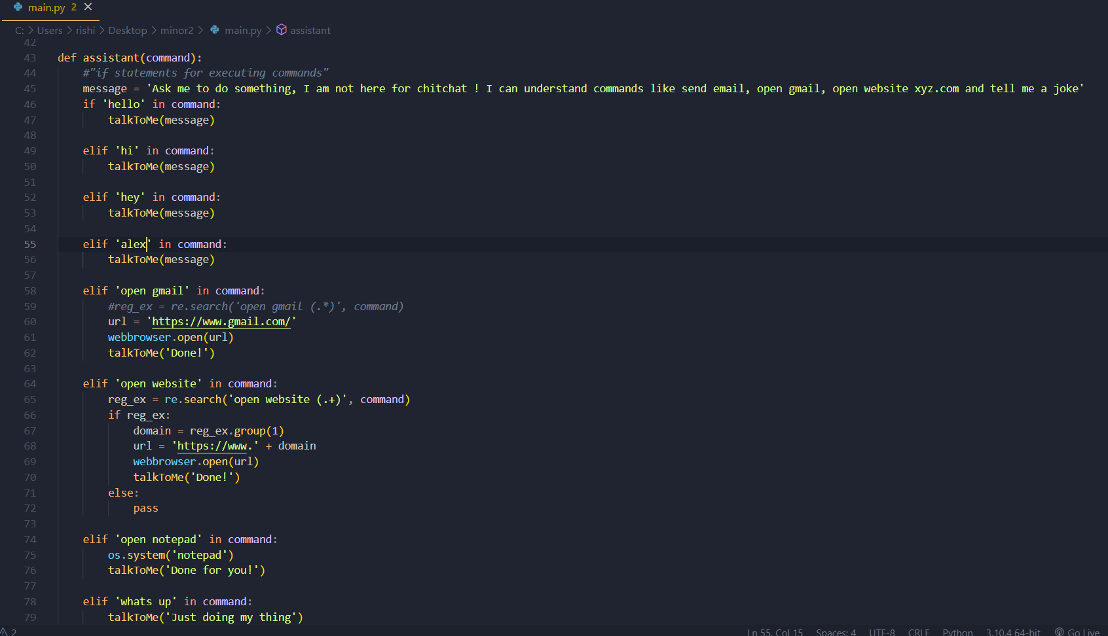

**Figure 3.4**

**3.4 Testing Process**

Testing is an integral component of the software development process. It entails a comprehensive assessment of a software to ensure it meets your client's requirements and goals. The primary goal of testing is to identify all the defects and errors in the software before the implementation phase.

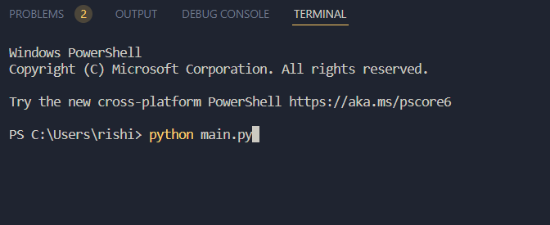

**Figure:3.5**

**4. RESULTS / OUTPUTS**

This project which is a virtual voice assistant named as “Alex” , can perform different task such as greeting user when started , opening gmail , can open any website on your voice command ,can open notepad by voice command and also can tell jokes when asked to tell.

**Virtual assistant greeting and opening Gmail**

User giving command through voice to open gmail and the voice assistant is performing the task of opening the gmail.

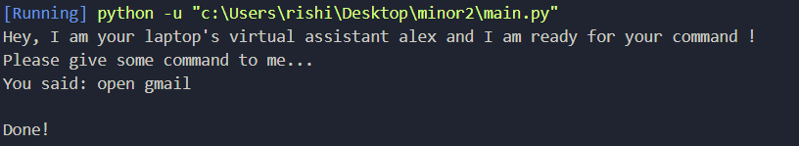

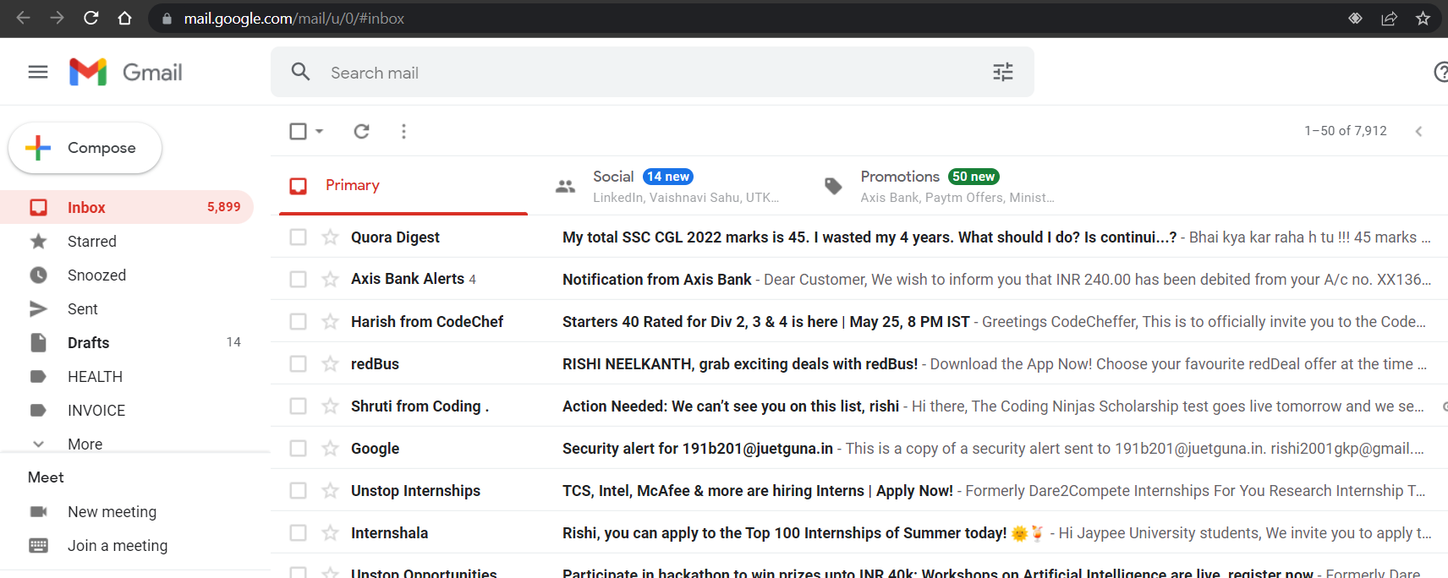

**Opening any random website**

The voice assistant is capable of opening any website on the users voice command .



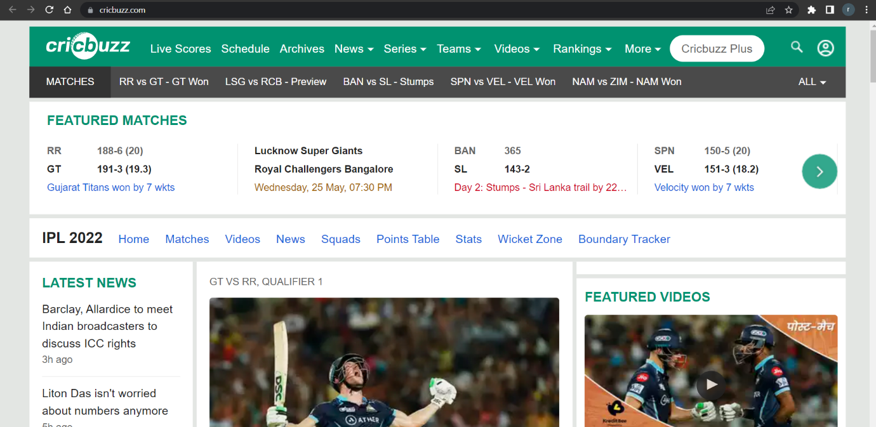

**Opening the notepad**

Virtual voice assistant can also perform the task of opening any operating system’s application using the user’s voice command

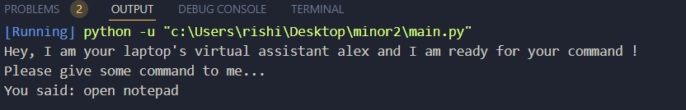

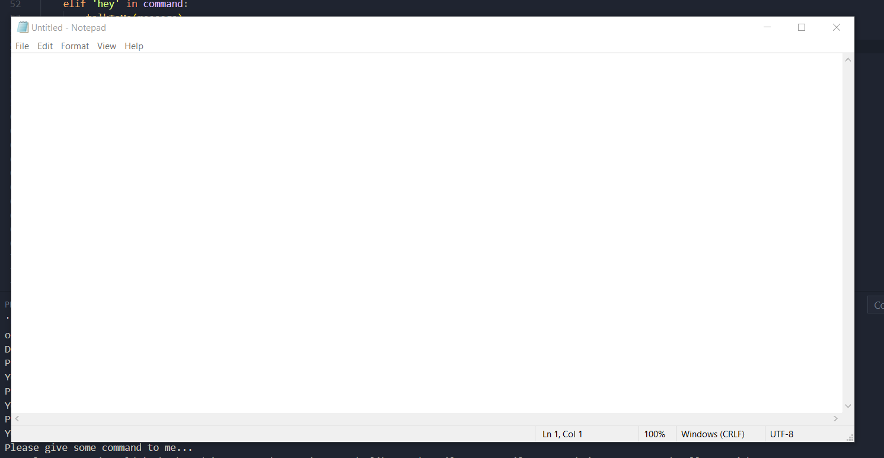

**Telling Jokes**

Virtual voice assistant can also tell you jokes whenever user commands the assistant to do so.

The voice assistant will speak the joke as well as print in text form .

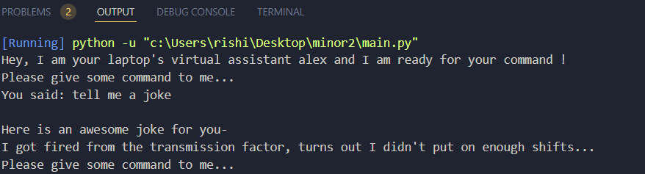

**5. CONCLUSIONS / RECOMMENDATIONS**

The conclusion describes the final product that we get after running the project and also describes it’s features , it’s services and it’s application.

* The expected outcome after the 6th sem will be the virtual voice assistant will be fully functional with all its functionalities.

* The implemented voice assistant can perform the following task it can open YouTube, Gmail, Google chrome and stack overflow. Predict current time, take a photo, search Wikipedia to abstract required data, predict weather in different cities, get top headline news , can answer computational and geographical questions and much more things.
* User can use it for its personal use which will help him do different day to day work hand free by just giving voice command to the virtual voice assistant.

**6. REFERENCES**

[1] <https://en.wikipedia.org/wiki/Google_Assistant>

[2] <https://en.wikipedia.org/wiki/Siri>

[3] <https://theassistant.io/guide/what-is-alexa>

[4] <https://www.python.org/doc/essays/blurb/>

[5] <https://pypi.org/project/gTTS/>

[6] <https://www.simplilearn.com/tutorials/python-tutorial/speech-recognition-in-python>

[7] <https://pypi.org/project/pycopy-webbrowser/>

[8] <https://pypi.org/project/pycopy-smtplib/>

[9] <https://www.geeksforgeeks.org/os-module-python-examples/>

**7. APPENDICES**

**7.1 Details of software/simulator used**

Project management software is software used for project planning, scheduling, resource allocation and change management. It allows project managers (PMs), stakeholders and users to control costs and manage budgeting, quality management and documentation and also may be used as an administration system.

**VS Code:**

Visual Studio Code is a source-code editor made by Microsoft for Windows, Linux and macOS. Features include support for debugging, syntax highlighting, intelligent code completion, snippets, code refactoring, and embedded Git. Users can change the theme, keyboard shortcuts, preferences, and install extensions that add additional functionality.

**7.2 Steps to execute/run**

These are step which is to be used to run the project and see its working.

* Open terminal and type python main.py

Virtual voice assistant will start responding and user can command using their voice.